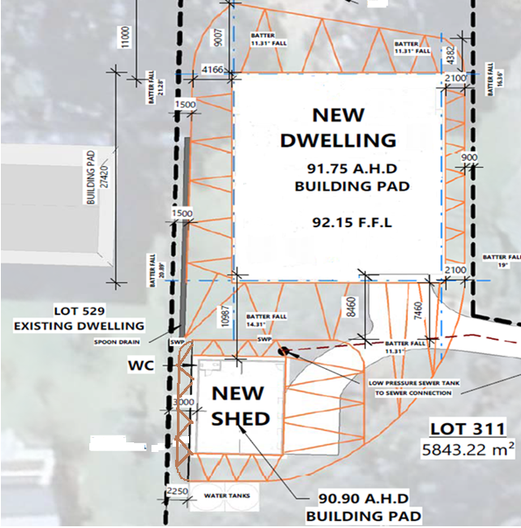
House Pad from River (North)
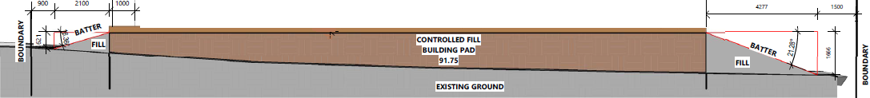
House Pad from East

House Pad from South
House Pad from West (Including distance between house and Shed Pad)

